Land Management System Requirements
- Land provider Profile- Rename Land Provider Master Data: Fields Required
- Father Name
- Permanent & temp address
- Fresh Picture attachment
- CNIC front & Back attachment
- Land Owner Profile – rename Seller Profile
- Permanent & temp addresses
- Land Category
- Rename mauza to mouza/chak No.
- Remove Land Provider name
- Remove Rows option, (Land Details)
- Attachments option, CNIC front & Back, Fresh Pic – 3 options
- Land Offer Form (Land Details) – Rename Land Form (seller)
- Mouza / Chak No
- Sector field
- multiple LO detail Fields
- Power of attorney (separate section) fields in case of Minor land provider (Name, Father Name, CNIC, Current & Permanent Address)
- Add Row fields same as in Seller profile master data (
- In case of Multiple Land Owners data will be shown in Rows
- Rate per acre field
- Purchase of Land
- Attachment of Massavi
- First field In add row Of “Land owner Code” multiple selection for lo name with lo code and name
- Total Amount field ( as /acre rate applied at land offer form)
- Formula for calculation of Total Amount will be provided by Land branch
- Fard ID, Date of Fard,
- ACRE rate as per DC, as per Actual
- Mode of payment selection field
-Exemption File
-Cash
-Hybrid

Fard Details Section:
- Fard Id
- Fard Date
- And along-side below details
Khewat No | Khatooni No | Block No | Rectangle No / Square No | Khasra No | Qatat | Measuring |  |  | Transfer Share | Land Measuring |  |  | Land Category
 |  |  |  |  |  | K | M | Sqft |  | K | M | Sqft
Auto fetch from Land Details Form | Auto fetch from Land Details Form | Auto fetch from Land Details Form | Auto fetch from Land Details Form | Auto fetch from Land Details Form | Auto fetch from Land Details Form |  |  |  | This must not repeat for same (Khatooni, Khewat, Khasra, Qatat) |  |  |  | Drop Down  (Ownership / Non Pata / Govt Land)

- Possession Certificate
- As in Word document
- Attachments field
- Pictorial View at the end of possession Certificate
- Remove separate form
- Registers Documents
- Conveyance deed
- Agreement
- Idemnity Bond
- Registery Document
Land branch will provide 1 set of Above 4 documents

New Changes
Land Provider Master Data
- Remove Exemption decimals
- Search option in list pages for all forms
Land Owner Profile Master Data
- Remove Land Category and mouza fields
- Remove Profile Picture 2
- Profile Picture 3

Land Offer Form (Land Details)
- Add selection field in Land Details land category with three option government land, pata land and ownership
- Remove Address field
- Tahsil and district field value is Bahawalpur by default
- Add remarks field in Power of Attorney (In Case of Minor Land Provider)

Purchase of Land
- Make Exemption Rate field from selection to manual input field
- Add 4 new fields District rate, DHAB rate , district amount(District rate * Acres) DHAB rate amount(DHAB rate * Acres)
- In Fard Details add one more field for fard date 2 and rename fard date field
- Auto fetch
Khewat No | Khatooni No | Block No | Rectangle No | Khasra No | Qatat | Measuring

- Multiple land owner auto fetch from land offer form
- In add and in edit page search option for land form number field
- Add cnic and contact number fields in POL add and edit form and also show LO fields in separate div and auto filled that fields on the basis of land form number field
Possession Certificate
- Auto fetch all detail which is available in purchase of land form
- In Possession Detail remove all fields Khewat NO
Mustatil No
Muraba No
Khasra No
Kanal
Marla
SQ Feet
- Add
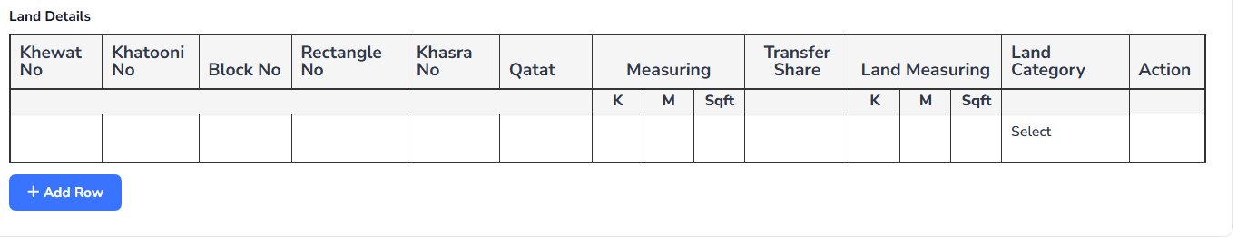
Auto fetch all data in above screenshot fields
Add 2 columns in above screenshots one is posseed land and unpossessed land and also add 3 column below of the above columns kanal, marla and sqft
Conveyance
- When I select Purchase of Land if I enter multiple land owner in purchase form and when I select Purchase of Land auto fetch multiple land owner
- Auto fetch
Transferred Share | Khewat No | Khatooni No | Qatat

Registry Document
- Add 2 new attachment field one is registry and second is Mutation
- Add 4 input field after lo cnic Registry No , Registry date, mutation no and mutation date
- Move challan fee , exemption rate and challan form in sidebar from purchase of land into exemption documents end

New points

Land Offer Form (Land Details)
Add Lo Code column in Land Detail
Power of Attorney (In Case of Minor Land Provider)
Rename to Power of Attorney (In Case of Minor Land owner)
Add lo code field in power of Attorney and make sure lo code is multiple selection

Purchase of Land
Remove
Block No | Rectangle No | Khasra No
From purchase of land

Possesion certificate
Remove
Block No | Rectangle No | Khasra No

Remove Transfer Share
Remove Measuring k, m, sqft
Calculation of unpossessed land
Add sector column
Remove all others Attachments only needs possession certificate
Remove area, Kanal,Marla field in Pictorial View

